What is docker ?

Docker is tool which creates container .

Container is like a virtual machine .

Docker used to name as docker engine .

Task of ops team is to deploy apps to server .

Dependencies – all the requiremnet eg : all version of sotware etc which are ready for creating application .

In virtualization , hypervisor will give momeory to vm from its host .

Previously it was not possible to share os with machine but with virtualization we can share image for further testing .

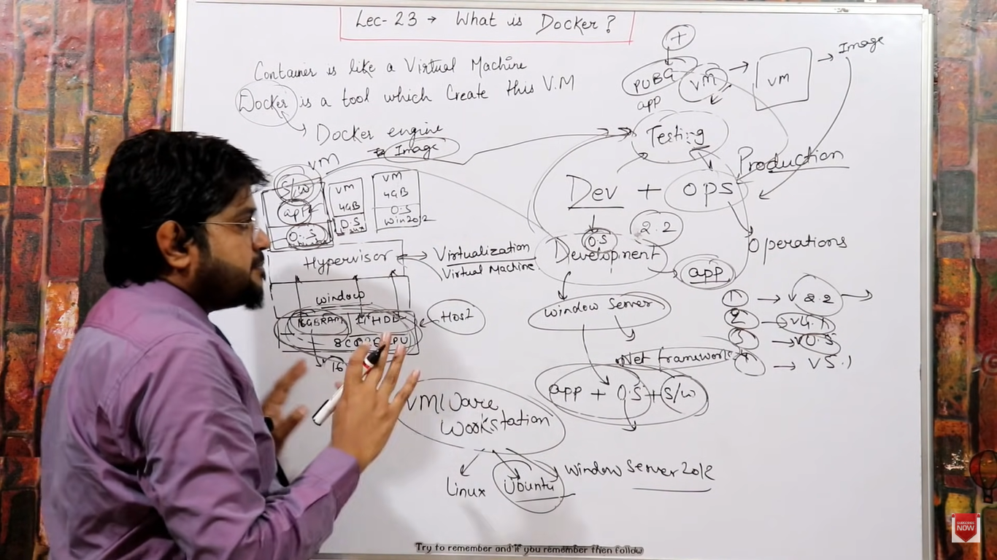

Docker is advance version of virtualization .

Work of docker is to do containerization .

Direct hardware p o hypervisor hota usqo type 1 bolte .

Hypervisor is intermediator.

In VM – we have to install os but container don’t have os - .

